

**Phore**

Proof-Of-Stake 3.0 privacy-based cryptocurrency with ZeroCoin Protocol

November 7, 2017

# 

# 

# Introduction

### What is Phore?

Phore is a digital privacy cryptocurrency with a focus on sustainable development and growth. Phore uses Proof of Stake and Master nodes to secure the network and provide for a deep level of privacy and security. Phore has relatively fast block times compared with Bitcoin and low transaction fees.

### Coin Information

Block Target: 60 seconds

Transaction Fee: 0.0001 PHR per kB

Block Maturity: 50

PoS Reward: 2.8 PHR

Masternode Reward: 4.2 PHR

Masternode Collateral: 10,000 PHR

### History

Phore is a digital privacy cryptocurrency, an update and rebrand of KryptKoin (KTK) which was pre-announced in May 2014, and whose distribution started on the 21st May 2014.

Kryptkoin was a non-premined coin, distributed equally to people who qualified for a stake. In total, 500 stakes were distributed in 2 stages. Bonus KTK was given to those who held for 30 days. There was no ICO, and no dev premine. The developer received 1 stake, the same as every other stakeholder received. Following launch, Kryptkoin quickly developed a large following and introduced an online marketplace in 2015, which included Paypal integration where digital items such as Wordpress themes and physical items such as clothes were both listed and bought.

To facilitate new features, the existing code needed to be rewritten from scratch. This required a swap from Kryptkoin to the new Phore.

A two-month window was given to existing KTK holders to swap their coins for new Phore on a 1:1 basis.

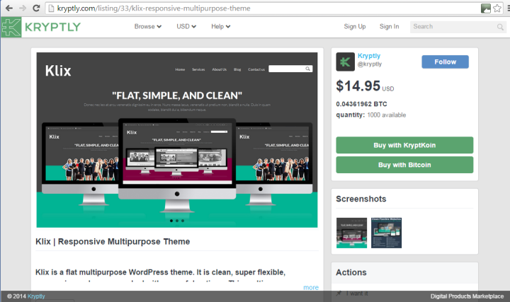

Kryptly, Kryptkoin's previous marketplace

### Team

The coin has a strong and committed team:

* Phroshi - Lead Developer
* Julian - Core Developer
* Fish313 - Technical Support & Social Media Manager
* Toby - Customer Relations & Social Media Manager
* Shanto - Community Manager & Customer Relations
* Liray - Technical Support & Japanese Community Manager
* Ubermaster - Planning and Partnerships

We will hire more staff and developers to strengthen our team as the Phore expands and evolves.

# Roadmap

Phore is a restless currency.

The key challenge going forward is to introduce real-world use which attract everyday people. In order to achieve this, Phore will implement advanced features to clearly differentiate Phore from other privacy based digital currencies.

A number of these will add to the functionality and strategic integration of the online marketplace, which will be built on the current foundations of Phore.

Governance will determine many of the goals going forward to keep the currency decentralized, but a decrease in Master node rewards per block is expected to decrease inflation.

Short Term (Q3 - Q4, 2017)

* **Zerocoin Protocol** - Fixes a major weakness within most digital currencies. With Zerocoin Protocol implemented within Phore, your purchases and transactions are secure and no one is privy to your financial activity.

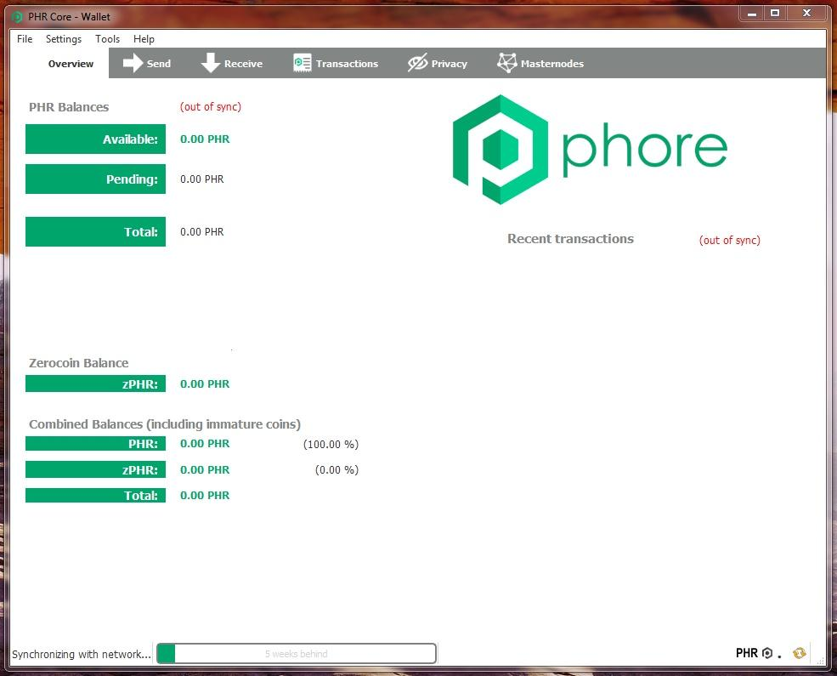

* **Masternode Governance** - Those with Masternodes would be given ‘yes’ or ‘no’ votes using commands built into Phore wallets. Decentralized governance will allow a crypto-currency network to grow, and incorporate democratic procedures that will ensure the longevity of the project, leading to a truly decentralized management system.
* **Online Marketplace** - UI compatibility for all devices.

Medium Term (Q1, 2018)

* **Segregated Witness** - Allows the number of transactions per block on the Phore blockchain to be increased. All signature data will be removed so that more transaction data can be packed in.
* **Decentralized Micro Crowdfunding** - Part of the Online Marketplace. A decentralized Kickstarter or Indiegogo platform, targeted at the 'side-hustle’ and micro-business generation. This means that the individual, partnership, or small startup with a brilliant invention or service can easily use the Phore platform to raise money, with much lower fees than other traditional platforms. We will also act as escrow until the product is received by the buyer.
* **Creation of the Phore Foundation** - Develop long-term e-commerce solutions, investments, partnerships, and to promote the sustainability and longevity of Phore.

Medium to Long Term (Q2-Q4, 2018)

* **Smart Contracts** - This will allow decentralized apps (dApps) to run on the Phore blockchain. Payment channels, trustless prediction markets, and decentralized exchanges are all things we expect to see.
* **iOS and Android apps** - Integrated wallets and online marketplace access. This will unshackle Phore from use on laptops and desktops to make it a true mobile-friendly platform.
* **Ledger and Trezor Support** - For long-term cold storage.
* **Phore Labs** - Incubator for Phore related projects to encourage development and growth through the Phore blockchain

The Phore Foundation will invest in projects to help them reach market and then reinvest profits in further projects. It is envisioned that ultimately 5-10% of the projects on the marketplace will be taken up by Phore Lab projects.

The Phore Foundation will actively seek out projects to support. These will be sourced from individuals, universities, start-ups, and cooperatives around the world who have the capacity improve the lives of others. Investments will be made in the form of Phore currency, and participants will sell exclusively through the Phore marketplace online for a fixed minimum period before being allowed to sell their product locally offline.

Long Term (Q4, 2018 and beyond)

* **A.I. Bot creation** - For trading support of Phore on exchanges.
* **Phore Foundation Scholarships** - Talented Coders will receive paid internships on placements at Phore.
* **Phore Foundation Charitable Donations** - Phore will be donated to charitable causes as voted by the Masternode Governance system.
* **Further Partnerships** - With industry-leading companies.
* **Event Sponsorship** - Sponsor Phore related events to promote Phore as a platform

# Other Information

### Official Website

[phore.io](http://phore.io/)

FAQ

<https://phore.io/faq/>

### Bitcointalk

<https://bitcointalk.org/index.php?topic=2307909.0>

### Discord

<https://discordapp.com/invite/Aucncz5>

### Twitter

<https://twitter.com/phorecrypto?lang=en>

### Facebook

<https://www.facebook.com/Phore-1996158580662988/>

### Github

<https://github.com/phoreproject/Phore>

### Masternode Statistics

<https://masternodes.pro>

<http://mnrank.com>

https://masternodeapp.com

**Phore © 2017**